1. 
2. 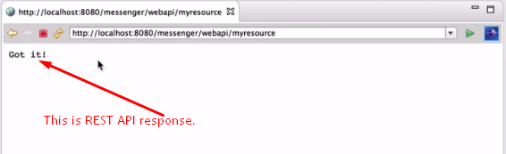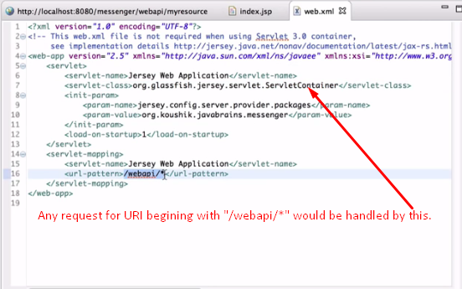  
   This part is standard in any JAX-RS app or something like this.
3. We saw that a RESTful API App is a standard servlet web app as we saw in the **web.xml** file.